**Image:**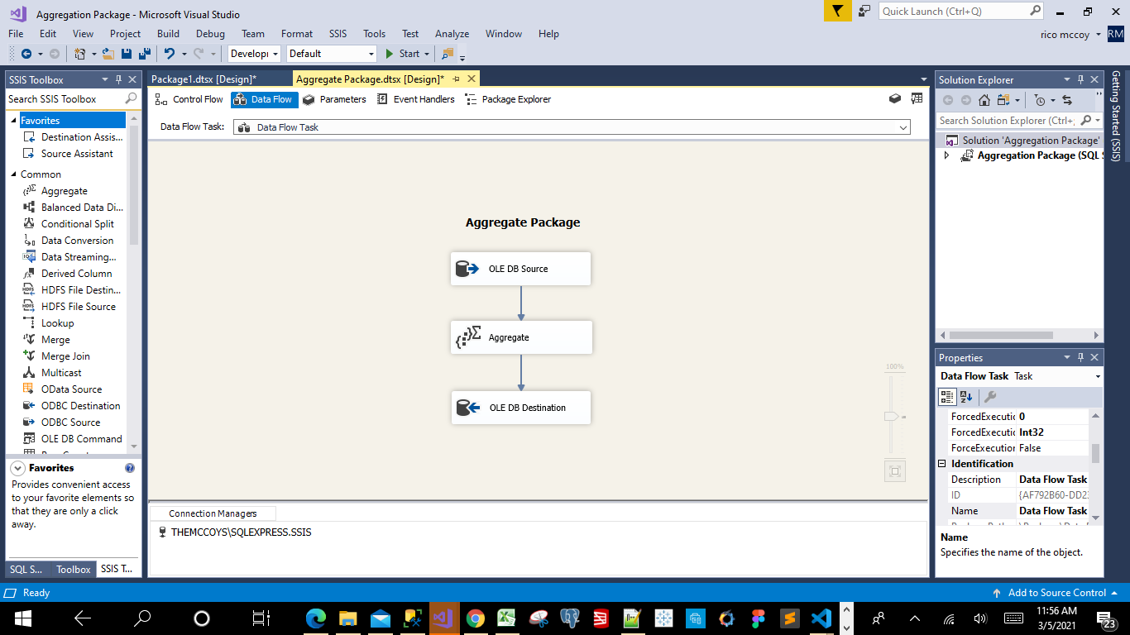

**After running the Aggregation Package w-Data Viewer Screen Shot:**

